Project Charter

Group-07

Project Title: Application for Vaccine registration
Project Start Date: 05/17/2021 Projected Finish Date: 06/03/2021
Budget Information: The estimated project cost is $20000.

Project Manager: Bala Shankar Malladi
s542419@nwmissouri.edu
+1 6605280317
Project Objectives:

The main objective of this project is to develop a user-friendly web application,
which allows the public to check the available slots to get vaccinated and to get register on the required date. This application also allows the hospital to check the data of people who registered for the vaccination and their health history.
Success Criteria:

1. Project should meet the Stake holder expectations
2. To create a user-friendly web application which allows the people to register for the vaccine easily.
3. Project should fulfill all the requirements defined in the scope.
4. This project should be completed within the given budget $20000, without compromising on the quality of the product.
5. Project should be completed within the deadline i.e 06/03/2021, by satisfying the stakeholder expectations.

Approach:
We would like to use the Agile methodology for completing the project. Daily Scrum meeting and regular interaction with the stakeholders to make the requirements clear and to avoid ambiguity with the team and stake
holders. In the web application we would like to use Angular for frontend development, Java for backend development and MySQL database to persist the data.

Roles and Responsibilities

Name and Signature | Role | Position | Contact Information
Bala Shankar Malladi  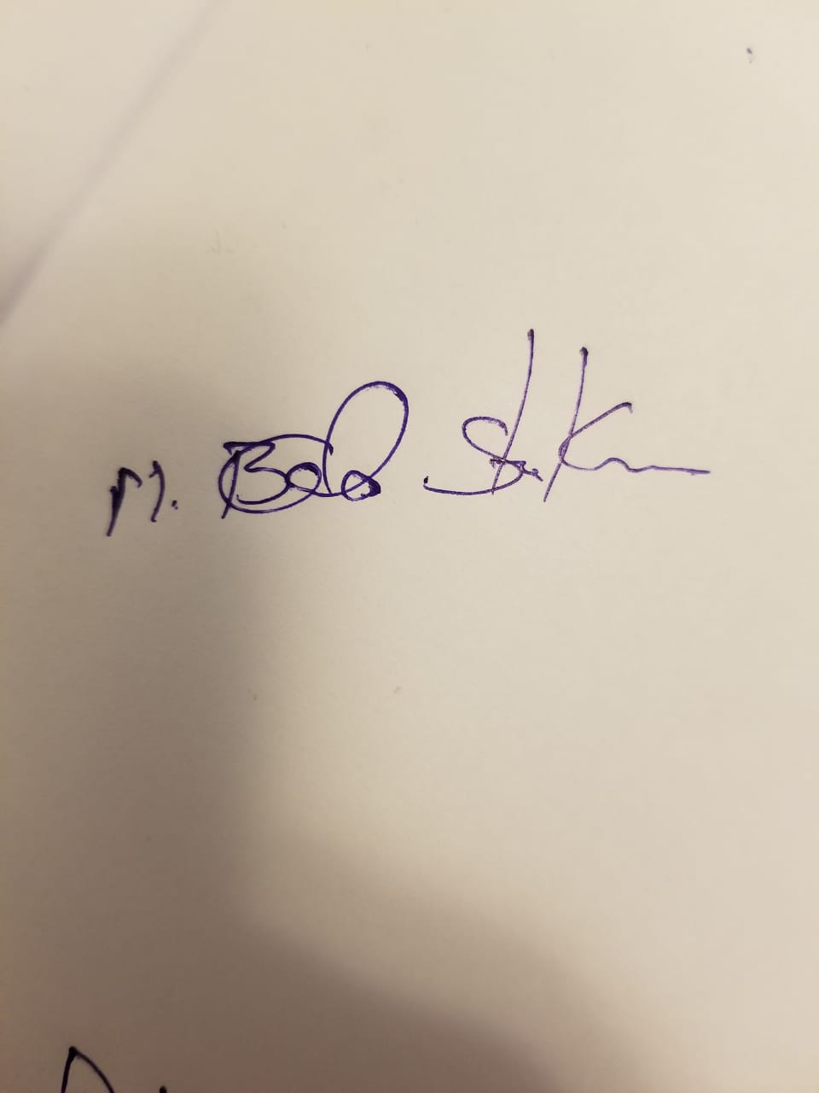 | Project Manager | Project Manager | +1 6605280317
Gahana Swetha Sanagala  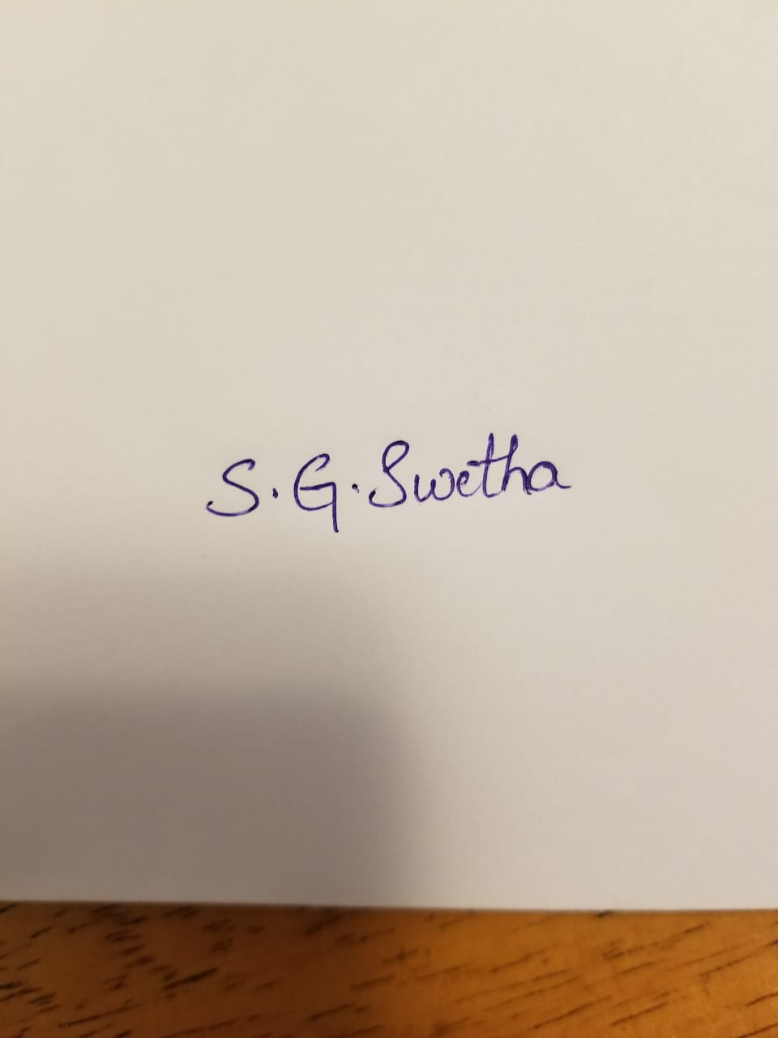 | Project Lead | Full stack  Developer(Java and Angular Developer) | +1 8167166709
Swarupa Pedapalli  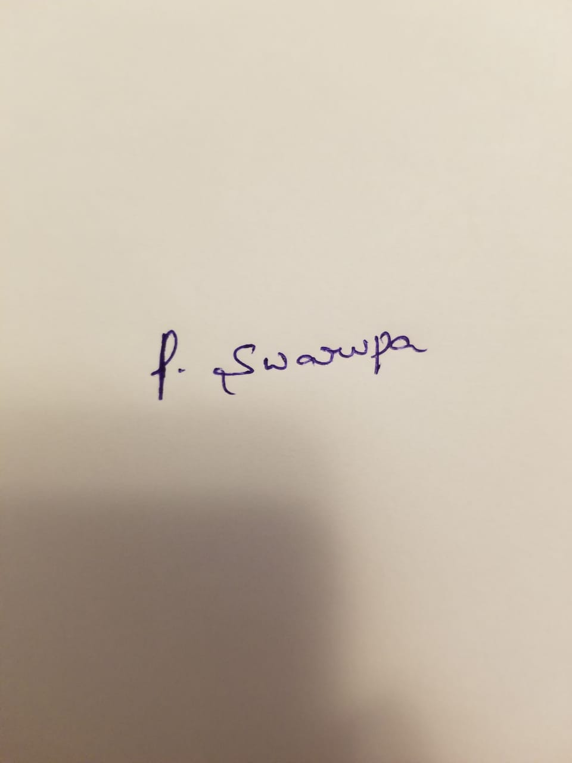 | Team Member | Backend Developer(Java Developer) | +1 6605281413
Venkat Sai Jarugula  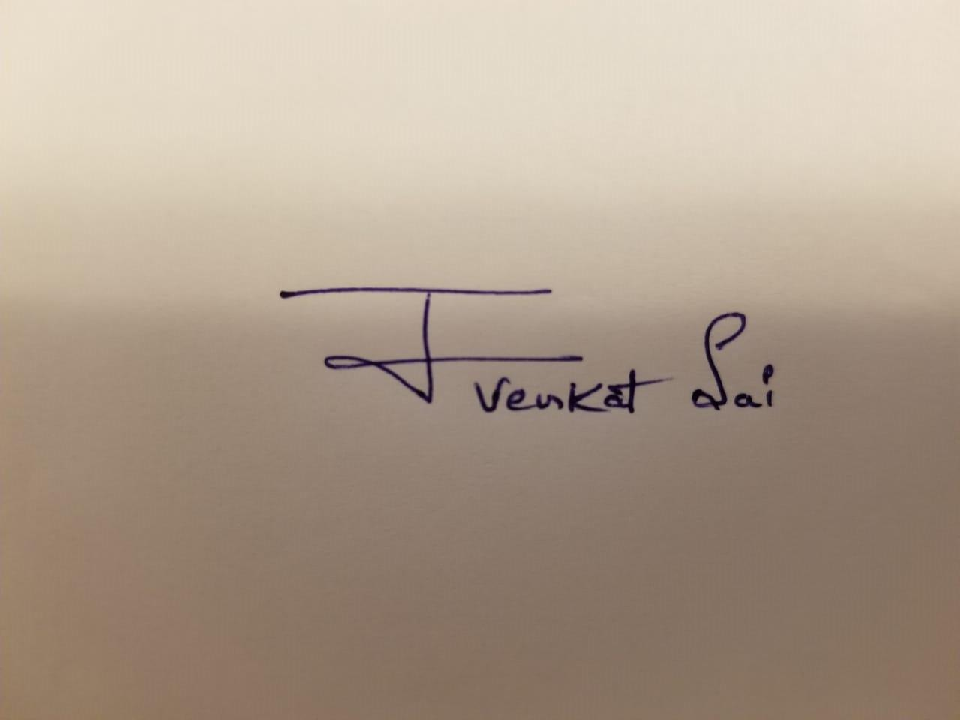 | Team Member | Front End Developer(Angular Developer) | +1 6605281431
Vivek Drakshapally  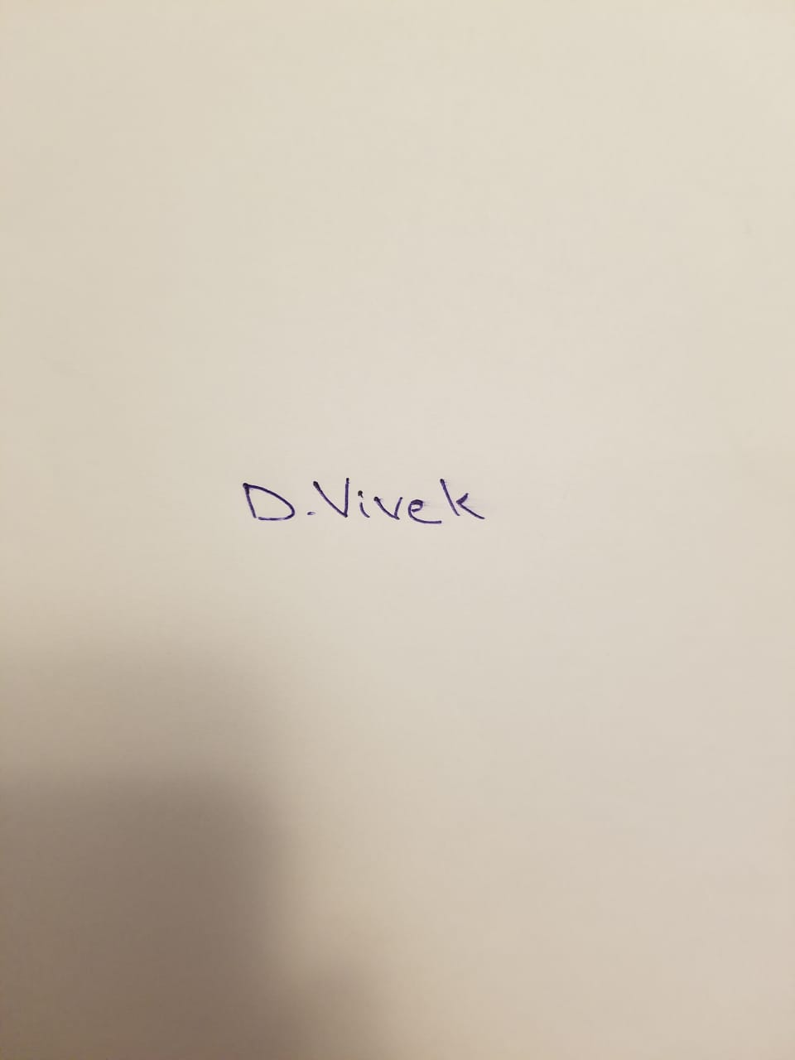 | Team Member | Database Developer(MySql Developer) | +1 6785779449
Comments: (Handwritten or typed comments from above stakeholders, if applicable)

